Arduino Lesson 12
LM35 Temperature Sensor
LM35 is a common and east to use temperature senor. Only one LM35 required in electronic applications, just use a analog interface. The difficult part is how to exchange the analog value to actual temperature by arithmetic.
- Parts Required
- LM35 x 1
- Breadboard x 1
- Jumper wires x 1 Bundle
- Connect-it-up
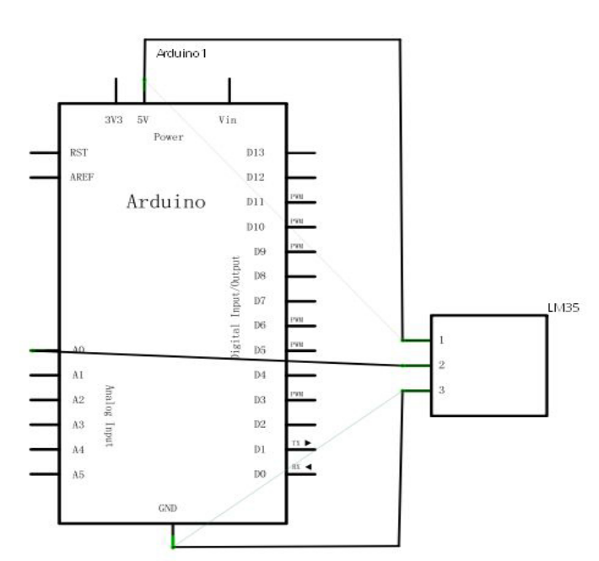
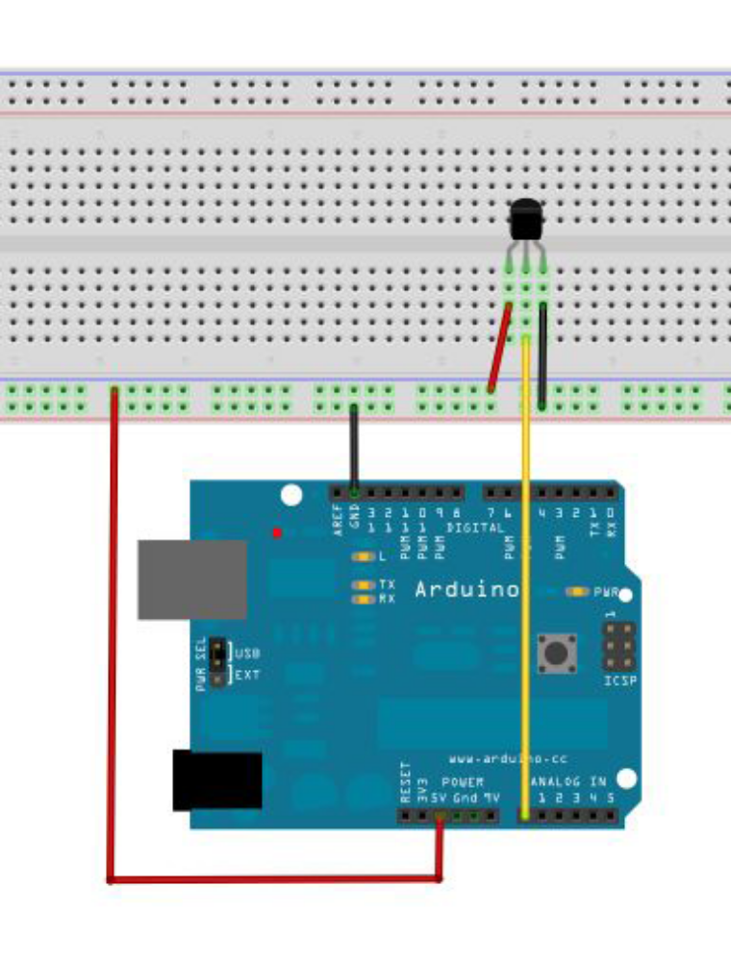
- Program for reference
int potPin = 0; //Set analog interface #0 accessed to LM35
void setup()
{
Serial.begin(9600);//Set baud rate as 9600
}
void loop()
{
int val;//
int dat;//define variable
val=analogRead(0);// read the analog value and assign to val
dat=(125*val)>>8;//temperature calculation formula
Serial.print("Tep:");//output character string Tep,stand for temperature
Serial.print(dat);//output dat value
Serial.println("C");//output character string C
delay(500);//delay 0.5 s
}
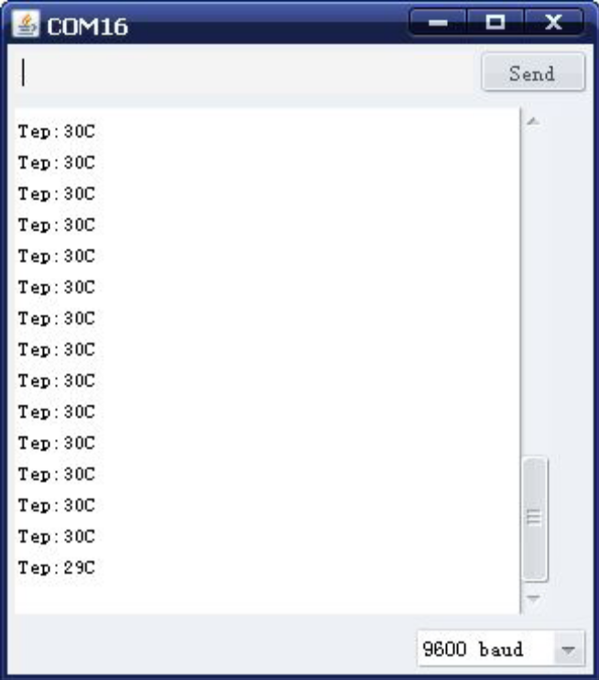
Download the program and open the besel then you can see the temperature.

